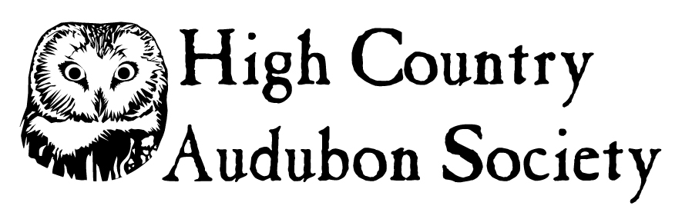
Sue Wells Research Grant Program 2021
Complete this application and submit with all required documents to
High Country Audubon Society by Saturday June 12, 2021

Name:

Street Address:

Town: State: Zip:

Phone:

Email:

High school, college or university you are attending:

Current or intended major:

Title of research project:

Application must contain 3 distinct parts:

(1) research proposal, including objectives and methods (no more than 3 double-spaced pages, use language understandable to non-technical reviewers);

(2) research budget showing total project costs, other sources of funding, and what portion of the total this award will cover, and;

(3) timeline indicating research schedule and when work will be completed.

Statement that directly addresses how the research is related to birds of this area and how information gathered will further the goals:

List two references (the first must be a current teacher or professor; the second should be a current or former mentor or employer who is not a family member):

Reference 1

Name:

High School / College / University:

Phone:

Email:

Reference 2

Name:

Affiliation:

Phone:

Email:

Please also include a letter from your academic advisor stating that:

a) you are a student currently in high school or registered for a B.S., M.S. or Ph.D. degree program, and

b) expenses potentially covered by this grant are not already covered by existing funds from other sources.

Complete this application and save the file so that your last name appears in the file name in this manner “HCAS Grant Application – NAME”. Attach the saved Word or pdf file to an email and send to: contactus@highcountryaudubon.org

Application and other documentation must be received by Saturday June 12, 2021

